*Florida International University*

*School of Computing and Information Sciences*

CIS 4911 - Senior Capstone Project

Software Engineering Focus

Feature Document

User Story #560

**Team Member:**

Andrew Mitchell

**Product Owner(s)**:

Francisco R. Ortega

**Mentor(s)**:

Francisco R. Ortega

...

**Instructor**: Masoud Sadjadi

# **User Story – Change Shapes with Eyes**

* As a User I would like the eyeX device to be able to read where I am looking so I can access certain functionality based on where I am looking.

## **Use Case – Change Shape**

Use Case

Be able to read which section of the screen the user is looking

Have 4 distinct sections.

Details:

Actor: User

Pre-conditions:

Touch screen working.

Program Running.

EyeX Running.

Shapes implemented.

Description:

Use case begins when a user presses a key (‘ ‘ space, Temporary until design philosophy is completed). This will alter the touch screen to draw rectangles, lines, circles, or triangles based on where the user is looking.The user story ends when the user successfully draws a new shape and lets go.

Post-conditions:

Shapes will be drawn on the touchscreen

Can be filled circles if filled mode is on.

Shapes depend on where the user is looking when he presses space.

Decision Support:

Frequency: Very High. This could be very core in our ‘ui’ changing based on where we look.

Criticality: High. The eyeX is a part of the smart desk. We need to learn to use this device.

Risk: High. The team member must use a brand new device properly.

Usability:

Know proper keybinding.

Get used to tobii EyeX eye tracking functionality (not 100% correct).

Reliability: Fairly.

Mean time to Failure – Not often. In the case where you are looking near multiple zones, you may get the wrong zone.

Availability – Always available (may change at a future date).

Performance:

Should swap shapes when we hit ‘space’

Supportability:

Must work with ACER Multitouch.

Modification History:

Owner: Andrew Mitchell

Initiation date: 02/8/2016

Date last modified: 02/14/2016

## 

## Use Case Diagram

## C:\Users\IEatR\Pictures\EyeX Shape Change Use Case.png

## **Sequence Diagram**

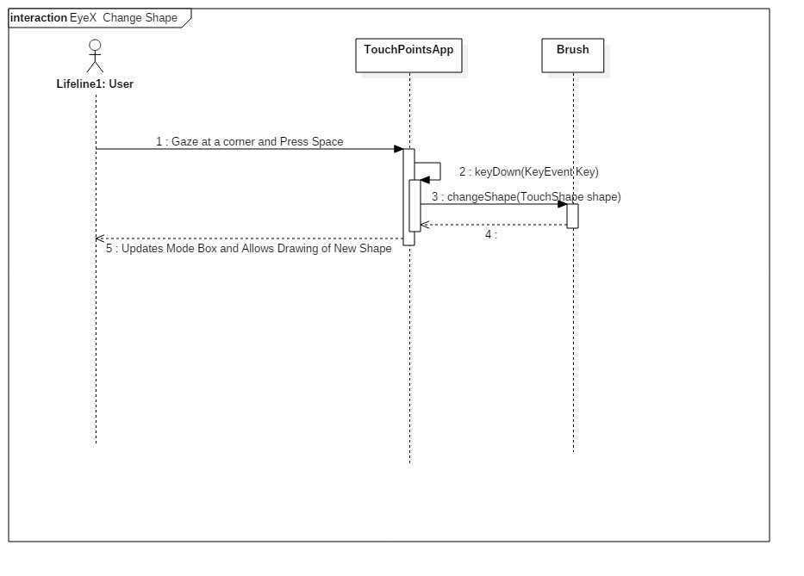

## 

## **Class Diagram**

## C:\Users\IEatR\Pictures\EyeX Change Shape Class.png

## **Unit Test**

Sunny Day Tests

Test Case: EyeX Shape Change

Test Purpose:

Ensure we can change shapes using the eyex and the spacebar.

Test Setup:

1. Begin the program with the EyeX Plugged in.
2. Move your gaze to the top right
3. Press space
4. draw
5. Move your gaze to the bottom right
6. Press space
7. Draw
8. Move your gaze to the bottom left
9. Press space
10. Draw
11. Move your gaze to the top right
12. Press space
13. draw

Test Output:

Drew 4 different shapes. A shape change occurred every space press.

Expected Output:

You should be able to draw 4 different shapes. Line, circle triangle, and rectangle

Rainy Day Tests

Test Case:

Test Purpose:

Ensure space doesn’t change shape when EyeX isn’t active

Test Setup:

1. Start program without EyeX
2. Look at the top right
3. Press Space
4. Draw

Test Output:

Drew a line

Expected Output:

You should not change shape, you should draw a line only.

## **Integration Test**

Works with current ‘touchpoints app’.

Currently integrated with the new ‘DeviceHandler’ class.

Works with enabling the mode box.

Works with enabling the top left UI buttons.

## 

## **User Guide**

You can see your gaze by the two little overlapping circles.

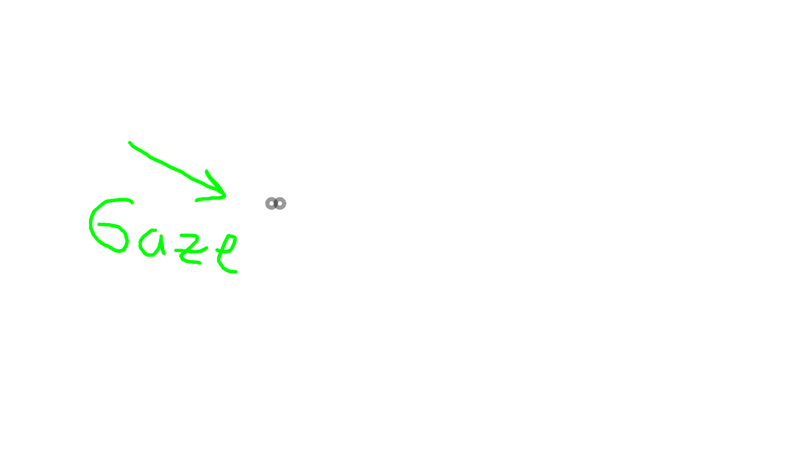

Moving the gaze to the four corners of the screen and pressing space (‘ ‘) will change the shape of your drawings! You can see what each corner corresponds to in the image below.

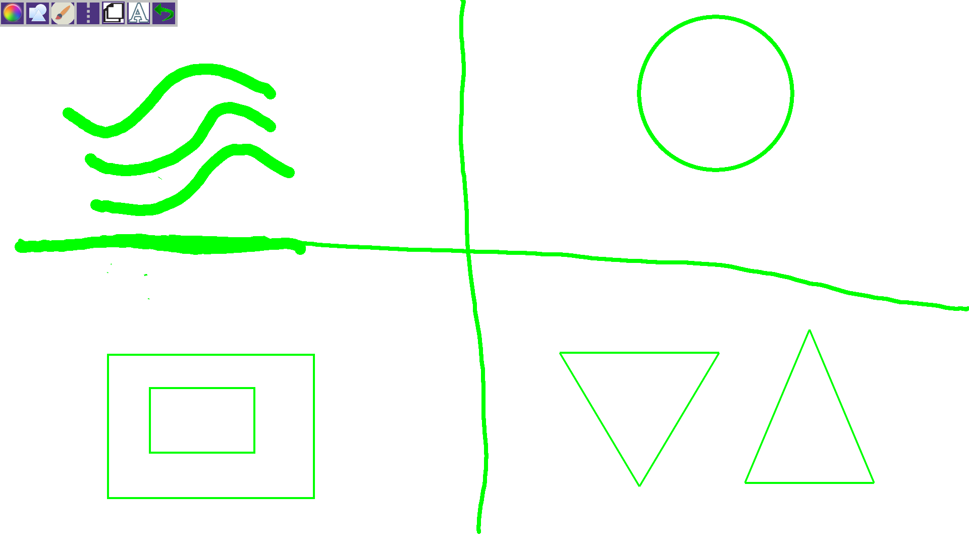

Top left – Lines

Top right – Circles

Bottom left – Rectangle

Bottom Right - Triangle

**Glossary**

N/a